XAMS User Guide

XAMS is our system for all e-Learning and e-Assessment. Within this User Guide you will find help on all activities within XAMS – if you need any further support, please contact the EUSR Support team.

For the XAMS Administrator:

- XAMS is fully integrated with QuartzWeb, our online registration system
- You will need to be logged into QuartzWeb in the role of ‘XAMS Administrator’
- You create activations for e-Learning and e-Assessment are created in a Batch within QuartzWeb
- Bulk activations can be made within a Batch
- You can track an individual’s progress in completing their e-Learning and e-Assessment as well as e-Assessment feedback reports
- You can extend an activation for an individual – you do not need to contact EUSR Support

Note: an ‘activation’ or an ‘activation email’ is what we call the email sent to an individual which gives them links to their e-Learning and/or e-Assessment. It is time bound (the date by which they must complete their e-Learning and/or e-Assessment is included in the email).

If an individual needs longer to complete their e-Learning, you can extend their activation yourself.

If you need additional XAMS Administrators within your organisation, please contact EUSR Support for an XAMS Administrator Registration Form.

For individuals taking e-Learning or e-Assessment:

- They can access XAMS via all web browsers but not INTERNET EXPLORER
- Access to their e-Learning or e-Assessment is via the EUSR website or an activation email sent by an XAMS Administrator
- They can resume e-Learning where they left off if they take a break (they do not have to re-take completed modules again)
- A free of charge re-sit is also still available if they fail the e-Assessment (they will need to go through the individual e-Learning modules they initially failed)
- XAMS is mobile enabled – the e-Learning or e-Assessment can be taken on an iPad or tablet but not a MOBILE PHONE

Contents
QuartzWeb

- Logging in and Passwords 3
- Switching Roles 4

Creating an XAMS Batch 4
- Send Activation Instructions 7
- Card Type Required 7
- Trainer Details (where visible) 7
- Purchase Order Number 7
- Batch Submission Confirmation 8
- Uploading Individuals to a Batch 8
- Bulk Registration 8
- Adding Individually 9
- Mobile Phone 10
- Email Address 10
- Card Type Required 10
- Confirm Individual Registration 11
- Uploading Photographs 12
- Notifications 14
- Activation Email 16

XAMS Administrator Role 17
Main Menus 17
- Home 17
- Schedule 17
- Administration 17
- Reports 18
- Extending an activation 19
- Withdrawing an activation 20
- Bulk actions 21
- Re-Setting Password 21

XAMS for the Individual 22
- Flagging questions 24

Appendix One – SCO Combinations and indicative timings 27

QuartzWeb

QuartzWeb is our online registration system. If you do not already have a QuartzWeb login, the EUSR Support Team will need to create one for you. Unlike some other roles within QuartzWeb, only EUSR can create the role of XAMS Administrator within QuartzWeb.

Logging in and Passwords

Each time you login to QuartzWeb you are required to confirm that you will comply with the QuartzWeb Terms and Conditions of Use.
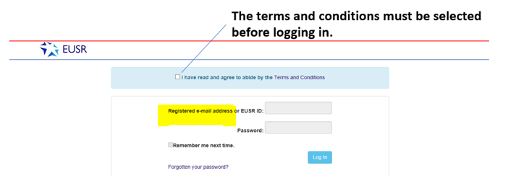

To login you need your EUSR ID number or registered email address. Your EUSR ID number is six digits or less.

Forgotten your Password?
If you have forgotten your Password, select the ‘Forgotten your Password’ link on the QuartzWeb welcome page and you will be taken to the ‘Reset Password’ page.

Enter your QuartzWeb Username (this is your EUSR ID number or registered email address) and select ‘Submit’.

You will receive an email containing a new password. If you still have difficulty logging in, please contact the EUSR Support team.

NOTE: The EUSR Support team will only reset passwords over the phone, never by email, as they will need to take you through some security questions.

Password Requirements
Your password must:

- Have 6 - 12 characters
- Include at least one digit
- Include at least one upper and one lowercase letter
- Include at least one special character (DO NOT USE £ the $ or @ ).

Switching Roles

Make sure you are logged into QuartzWeb as ‘XAMS Administrator’

If you have more than one role – because you need to perform different functions in QuartzWeb - you will need to switch from one role to another.

If the XAMS Administrator role is not listed, please contact EUSR Support.

Note: anyone with a ‘Lead Administrator’, ‘Administrator’ or XAMS Administrator role in QuartzWeb can create Batches BUT only an XAMS Administrator has access to XAMS.

Once logged in, click on the main tab which details the role you are currently logged in as. A ‘Switch Role’ dropdown menu will appear. Select the correct role and click on the ‘Switch Role’ button.
Click here to switch roles

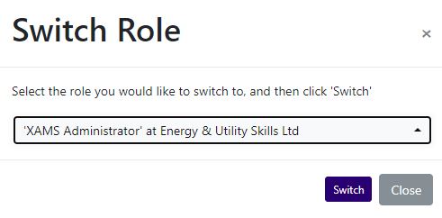

Creating an XAMS Batch

Before you can send any XAMS activation emails, you will need to create a Batch within QuartzWeb.

Mandatory information for each individual in the Batch:
- First Name
- Last Name
- Date of Birth
- Employer name (not mandatory but advised)
- Mobile phone number

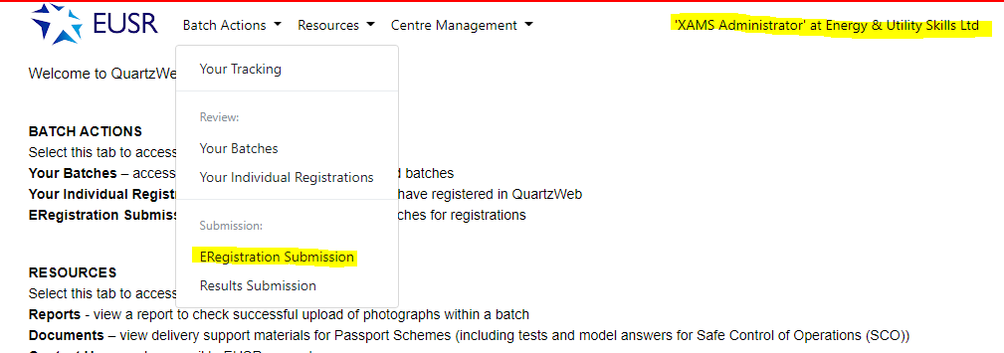
To create a Batch, select ‘Batch Actions’ and ‘ERegistration Submission’.

All XAMS programmes are called ‘eLearning/eAssessment’. You will be asked to select the ‘programme/course of learning’ from the drop-down box.
If the relevant e-Learning/e-Assessment programme is not listed, please contact EUSR Support. The second drop down box will automatically populate with relevant details. Select ‘Continue’.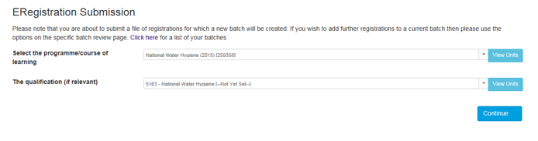The next page contains the XAMS ‘course booking’ information. This must be completed to create the ‘course booking’. Any sections that are not completed will be highlighted red.

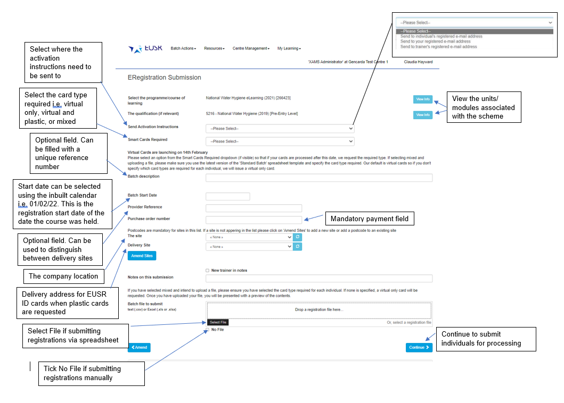

Send Activation Instructions
You can choose where the XAMS activation links are sent:
- An individual’s registered e-mail address (this is the e-mail address registered in QuartzWeb)
- Your own registered e-mail address (this is the e-mail address registered to the XAMS Administrator booking the course)
- The trainer’s registered e-mail address (this is the e-mail address registered to the Trainer listed against the Batch). This option can only selected if the trainer field is visible and a trainer is selected.
Note: Any e-mails that are added to QuartzWeb at the time of booking the course will become the individual’s registered email address.
Card Type Required
This is a mandatory field. The type of smart card required will apply to all individuals in the batch. You must select one of the following options from the dropdown list.

Virtual and Plastic – Select and all individuals in the batch will receive a virtual card and a plastic smart card.
Virtual Only – Select and all individuals in the batch will receive a virtual card only.
Mixed – specify at individual level - This option is where some individuals in the batch need a virtual card only and others need a virtual card and a plastic smart card. This option can also be used if you don’t know which cards are required when you create the batch. If this option is selected, you must select the type of smart card requested for each individual in the batch, further details below.
Trainer Details (where visible)
This is a mandatory field, where visible and when the activation e-mail option “Send to trainer’s registered email address” is selected.

Purchase Order Number
This is a mandatory field. The Purchase Order number you provide will appear in our invoicing documentation.

If you do not wish to pay by Purchase Order you have other options:
- BACS – if this is used please input, for example, ‘Paid by BACS on 31/03/20’
- Credit/Debit Card - if this is used please input, for example, ‘Paid by CARD on 31/03/20. Note: to pay by Card you will need to pay by telephone – contact EUSR Support

Please note that we will invoice the centre that has made the registration in QuartzWeb. We will not invoice third parties.

If you are booking a SCO module combination programme, a second page will load, where you can select the modules the individuals will be completing.
For further information on this please see ‘SCO Combinations’

Batch Submission Confirmation
You will be taken to a summary page – please review the information to ensure it is correct. If you would like to amend the information, select the blue ‘Amend’ button and this will take you back to the previous page.

If the information is all correct, select ‘Submit’ and an EUSR Batch number will be created. The Batch can be amended by selecting ‘Batch Actions’ and ‘Your Batches’.
Uploading Individuals to a Batch
Individuals can be added in bulk using the Batch File, or on an individual by individual basis.

Bulk Registration
To submit multi-registrations in the same Batch use ‘Standard Batch Submission Form’ – this is found by selecting the link at the foot of the first Batch Submission page. This template can also be found in the ‘Resources’ and ‘Documents’ menu.
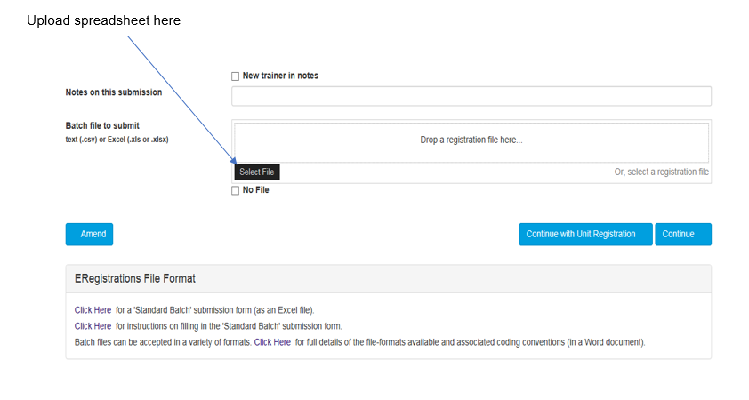
Once uploaded a preview file will be available to view.

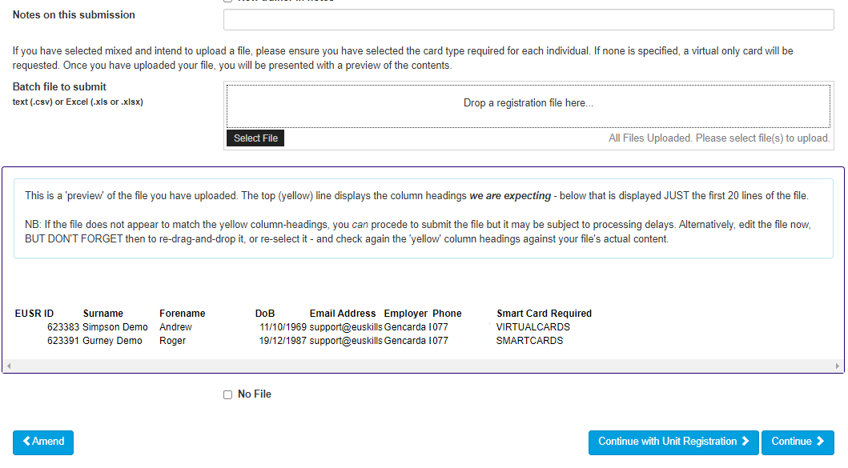
Once uploaded and correct. Click ‘Continue’ to confirm.

The “Smart card required” field in the Batch File must be completed for each individual in the batch if “Mixed – specify at individual level” was selected when the batch was created.

Adding individually

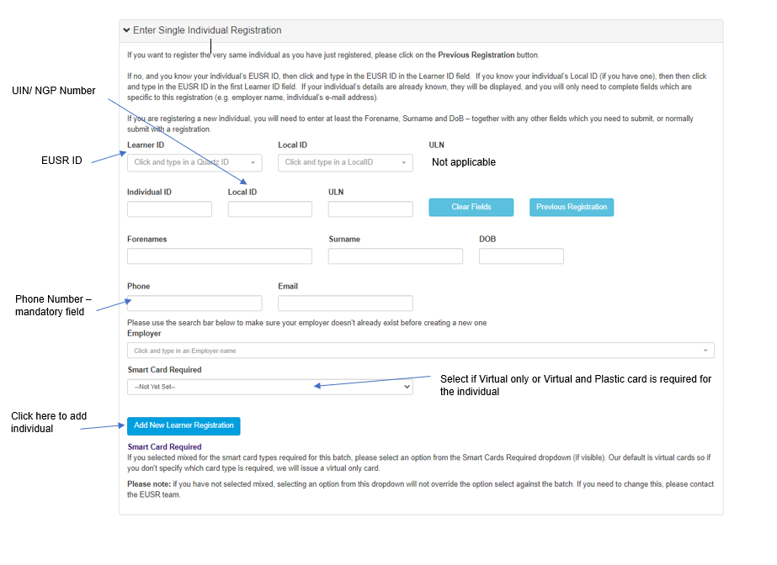
Individuals will appear in the ‘Enter Single Individual Registration’ section.
If the EUSR ID number is known, fill in the ‘Learner ID’ and select the record. This will automatically load below the ‘Learner ID’ box and automatically fill the fields on the page.
Mobile Phone
This is a mandatory field for virtual cards and plastic smart cards. The individual’s mobile phone number, either a work or personal, is required.
E-mail Address
A valid email address is required to send the XAMS activation e-mail directly to the individual.

Card Type Required
The “Smart card required” field must be completed for each individual in the batch if “Mixed – specify at individual level” was selected when the batch was created. You must select one of the following options from the dropdown list.

Virtual and Plastic – Select and all individuals in the batch will receive a virtual card and a plastic smart card.
Virtual Only – Select and all individuals in the batch will receive a virtual card only.

Confirm Individual Registration
Once all individuals’ details are added select ‘Add New Learner Registration’
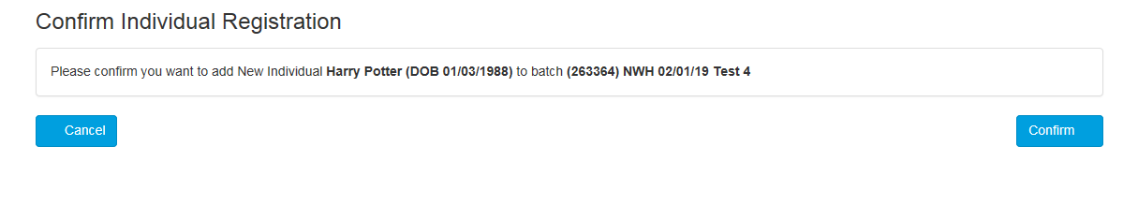
Once added to the batch all individuals’ records will be visible.
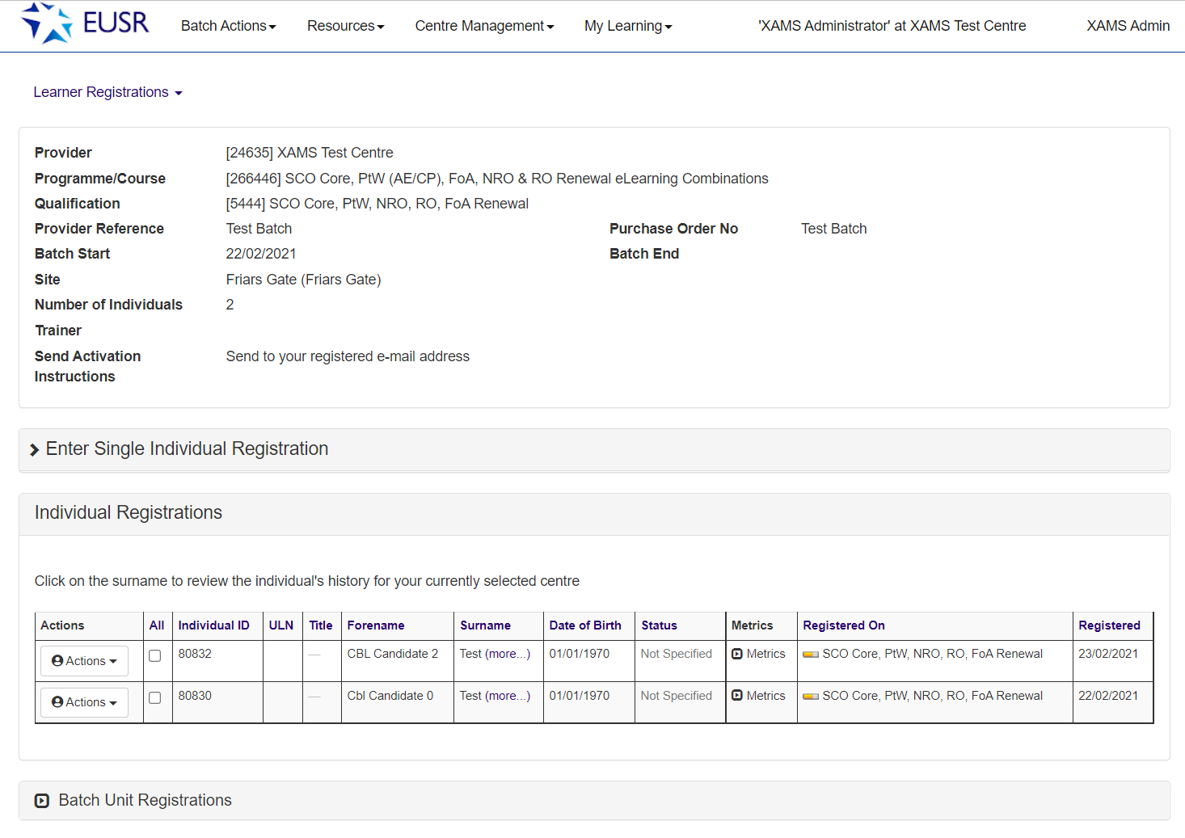
Once uploaded all individuals will appear in the Batch. An individual’s details can be reviewed by clicking against their name.

Uploading Photographs

How to Upload a Photo
Before a registration is ‘live’ on EUSR, a photograph and any scheme evidence (if this is a requirement of the scheme) must be uploaded against the individual. Please ensure the photographs you upload comply with our Photograph Guidelines www.eusr.co.uk/support-faqs/provider-and-trainer-support/photograph-guidelines

An example of an acceptable photograph

Add all individuals in the Batch before uploading photographs.
To upload a photograph, select the ‘Actions’ button
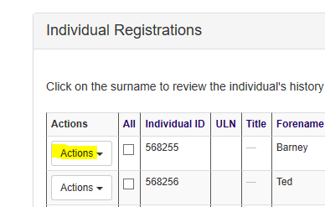

Select ‘Add ID Photo’

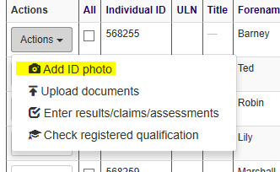

You will then be able to ‘Upload Photo ID’. The photograph file can be ‘dropped’ into the drop-box or you can search for the photograph from within your folders using ‘Select File’.

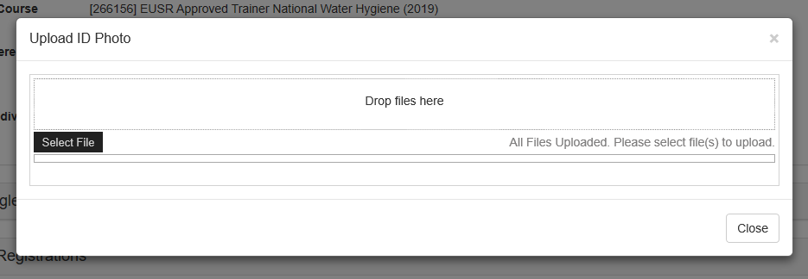

Once a photograph is uploaded, the ‘Photo Cropping’ tool opens.

Photo Cropping
The photo can be edited to fit within the guidance lines.
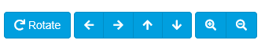

The photos can be rotated, moved, and zoomed in/out.

Once you are satisfied with the editing, select ‘Save’ and then ‘Close’.

The ‘Actions’ button will then show a green silhouette once the photograph has successfully uploaded.
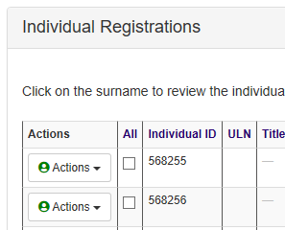

A drop-down option is available, ‘Show ID photo’

Select this to view your upload.
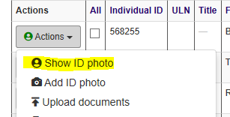

The photograph is retrieved and will show on screen.

Notifications
If you see a blue ‘bell’ icon in the top right of QuartzWeb home page, this means action needs to be taken.

Click on the icon and information is displayed which provides a brief description of the issue and the individuals details.

To delete Notifications, click on the ‘X’ against the specific notification you want to delete.

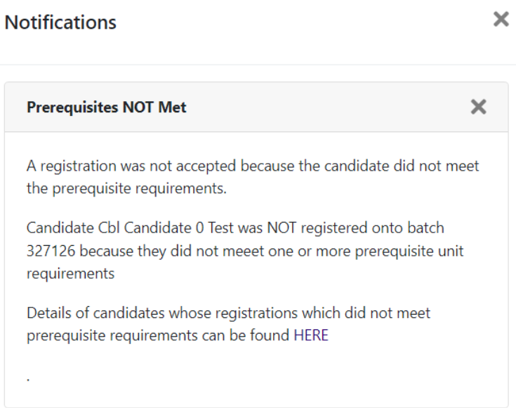
In the above example, if you select ‘HERE’, a ‘Reports’ page opens, and you will see all individuals that have not met the prerequisite requirements for the relevant XAMS courses. A ‘Prerequisite Report’ is also in the ‘Reports’ page. To access, select ‘Resources’ and ‘Reports’.

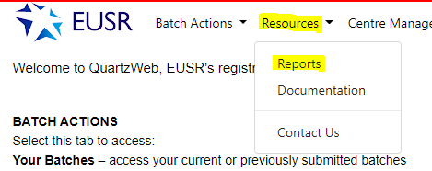

The report is named ‘Registrations not meeting prerequisite requirements’

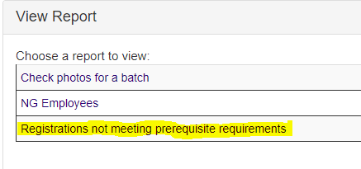
This report can be filtered by date and displays the ‘Batch Number’, ‘EUSR ID Number’, ‘Individual’s Name’, ‘Course’ and the ‘Date Registered’.
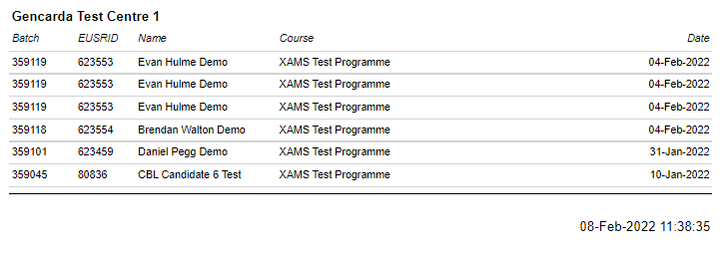

Activation email
Once an individual has been registered in QuartzWeb, for an e-Learning/e-Assessment programme, an automated activation email is sent.

The email is sent to whichever email address was selected at the time of creating the Batch, the individual’s email address registered in QuartzWeb, to the XAMS Administrator or to the Trainer (if option available).

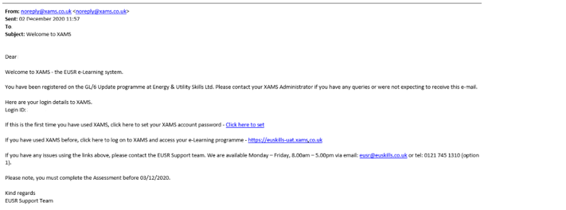
If the individual has never used XAMS before they will need to follow the link to create their XAMS password.

If the individual has used XAMS before they can continue to the XAMS login page.

XAMS Administrator role

When first registered in XAMS Administrator role, you will be sent a welcome email.

Main Menu
The ‘Home Screen’ consists of different areas.
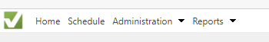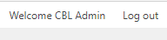

Home
In ‘Home’ you can select the different pages.

Schedule
In ‘Schedule’ you can see the individuals who have been scheduled for e-Assessments. It will confirm:
- Start date
- Centre
- Assessment (the e-Assessment that has been sent out eg National Water Hygiene)
- End date (the date the e-Assessment was completed)
- The duration of the assessment (length of time allocated to the e-Assessment)
- Course completion status

The Schedule list can be filtered by date and can also be exported into an Excel document.

Administration
In ‘Administration’ you can view Cohorts (Batches) and individuals assigned to your Centre that have been sent e-Learning or e-Assessments through XAMS.
- Users – on this page you can view all individuals under your centre. The information can be filtered by date, role (eg and exported to an Excel document. You are
able to filter by role eg student (individual) or admin (XAMS Administrator).
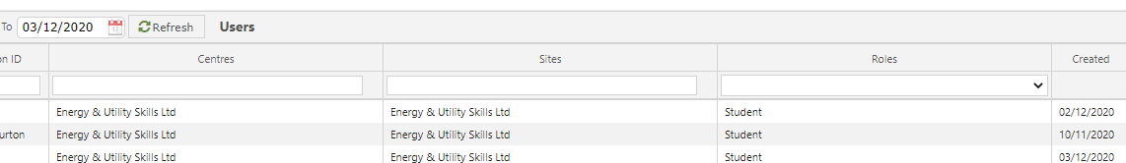

- Cohort – This page enables you to view all Batches that have been created. You can see the Batch number and the date it was created.

Reports
In this menu you can view:

- Results – The individuals assessment result and the gradings.
- e-Learning – This report shows all individuals who had assessments created. The report shows the ‘Learner Names’, ‘EUSR ID number’ ‘Start Date’ and ‘Completion Date’.
- Scheduled Learners – This report shows all individuals who are due to take an e-Assessment. It also highlights the e-Learning/e-Assessment programme that has been selected for them and when the activation will expire.
- Learning Registration Report – This report shows individuals who have been activated for e-Learning/e-Assessment programmes and by clicking on the arrow, activation emails can be resent to the XAMS registered email address and activations can be extended
- Course Progress Report – This report shows the status of individuals. You are also able to view the Batch Id, individuals Registration date, Individual’s link Expiry Date.

The statuses include:
- Assessment Completed (resit scheduled) – Individual has completed the first assessment but has failed, a second attempt has been scheduled
- Assessment Started – Individual has started the final assessment
- Assessment Started (Resit) – Individual has started the final resit assessment
- Course Completed (Passed) – Individual has completed and passed the course
- Course Completed (Failed) – Individual has failed the course and is required to undertake further training
- Course Completed (Failed eLearning) – Individual has failed part of the eLearning (i.e. the NWH Health Screening)
- eLearning Started – The eLearning modules have been started
- eLearning Completed – The eLearning modules have been completed, the individual can now take the assessment
- Registered on Course – Individual has received the course activation link but not started learning

All these reports can be filtered by Date, Name, Assessment Type eg National Water Hygiene. They can also be exported into an Excel spreadsheet.

Extending an activation
Under the Reports tab, select “Learning Registration Report”
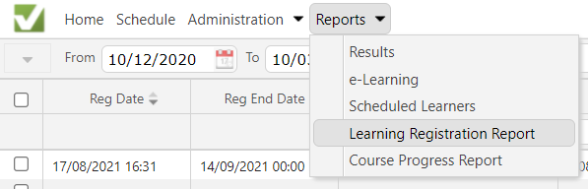
To extend an activation, click on the arrow at the end of the row for the individual you would like to extend.
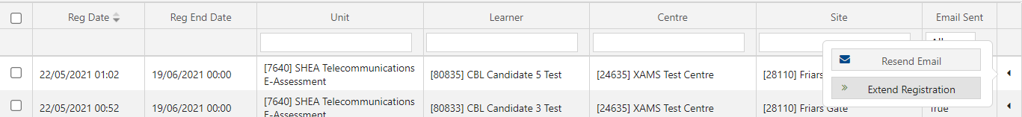
A small window will appear with the option to Resend Email and Extend Registration. Click the Extend Registration button.
A pop-up window will open where you can change the date. You can either type the date in (dd/mm/yyyy) or click on the calendar icon to select from a calendar view.
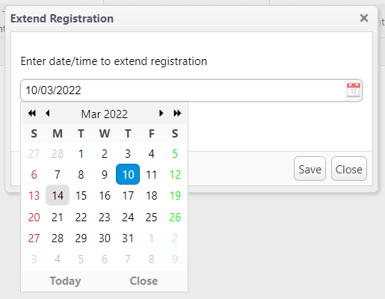
Please note: The date must be in the future.
Once you have entered/selected the require date, please click Save. A pop-up will appear confirming the registration has been extended. Click OK.
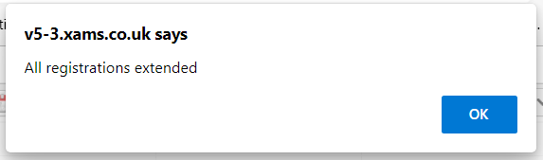

The report will refresh and show the extended date.
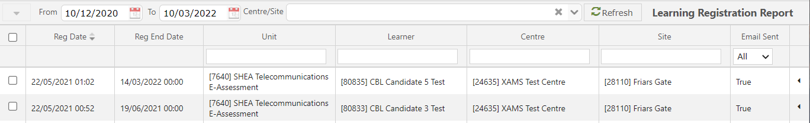
It is recommended that you then resend the activation instructions, which will list the extended date as the expiry date.

Withdrawing an activation
Withdrawing activations can only be done by the EUSR Support Team, however, you are able to expire activations, which will prevent the learner from accessing the eLearning and/or eAssessment. Follow the steps to extend an activation, leave the date/time as today and click Save.
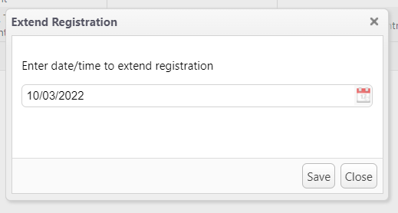
Click OK on the pop-up confirming the activation has been extended and the report will refresh showing the Reg End Date as the current timestamp.
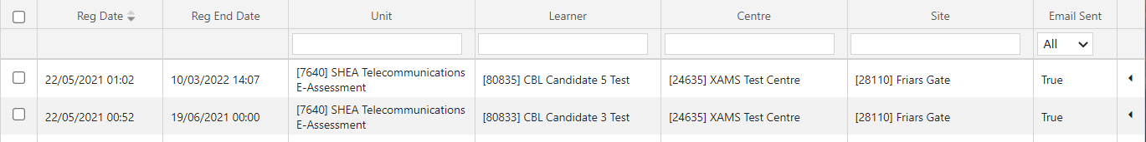

Bulk actions
This action is for when you want to extend or resend emails to multiple individuals; you can di this by clicking the checkboxes on the left for the relevant individuals.
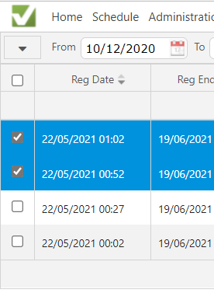
Click on the dropdown arrow at the top, next to the “From” field.
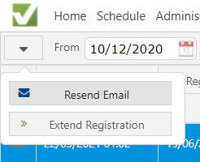
Select the relevant option and follow the steps as normal for these actions.

Resetting password
If you click on ‘Welcome (Your Name)’, you can reset your password.
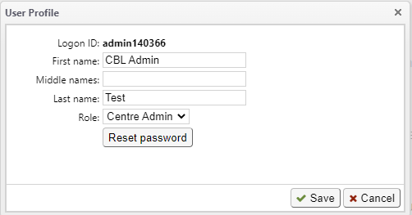

XAMS for the Individual

This section of the XAMS User Guide explains what the individual will see when sitting an
e-Learning/e-Assessment programme.

The individual (or the XAMS Administrator) is sent the email activation.

New individuals must create a password using the link found in their ‘Welcome’ email.

Individuals who have sat e-Learning/e-Assessment programmes before will be able to login and start the e-Learning/e-Assessment by selecting the link on the ‘Welcome’ email.

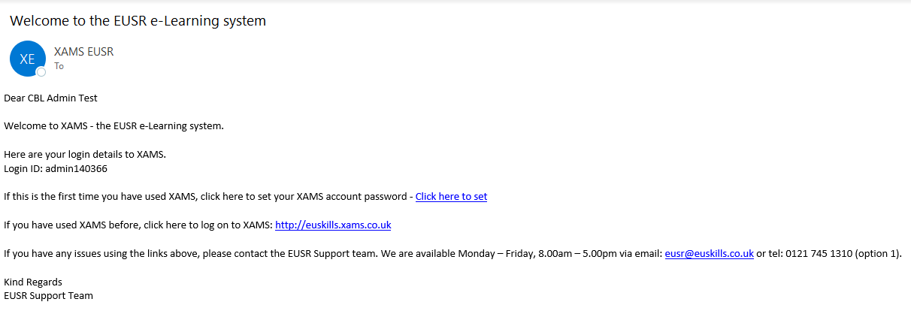

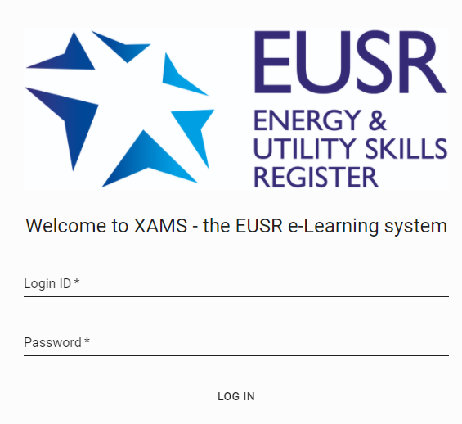
Once logged in, the individual must confirm their own details and they have read the instructions. For some e-Learning/e-Assessment programmes they may have to confirm additional statements as well.

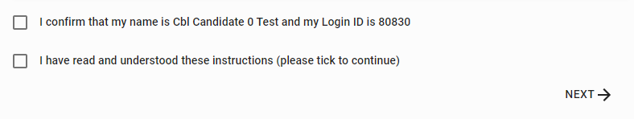

This page confirms the e-Learning/e-Assessment programmes the individual must complete.

Once ‘Start’ is selected, the e-Learning programme opens and displays the modules. The individual is then able to start.

To move onto the next module, the previous module must be completed first. Once all modules are completed the individual can return to the ‘Schedules’ page and sit the final e-Assessment.

Prior to sitting the e-Assessment, the individual must read the Assessment instructions.

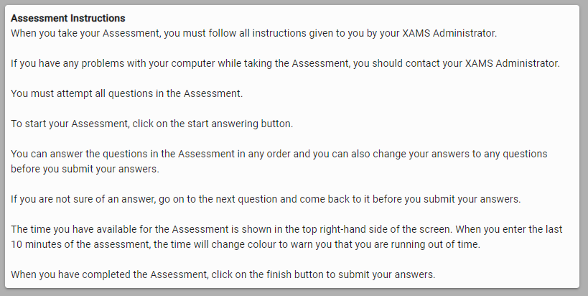

The individual has a set time to complete the e-Assessment (this varies depending on the programme but will be between 30 and 45 minutes). If an e-Assessment ‘times out’, then XAMS automatically marks the answered questions and grades accordingly.

Flagging Questions
All questions can be selected from the left-hand side of the page. During the e-Assessment the individual can read through all questions. If unsure about a question, they can ‘flag’ that question and go back to it later in the e-Assessment.
Questions can be ‘flagged’ by selecting the ‘Bookmark’ icon on the right of the page - below where the time remaining is displayed.
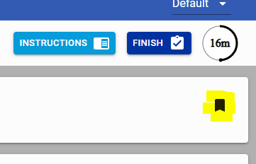
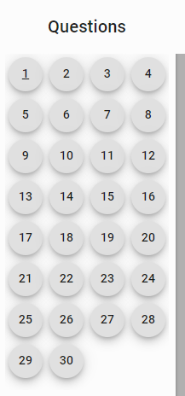
If a question is ‘flagged’ the relevant tab on the left-hand side will highlight. These do not need to be ‘unflagged’ to complete the test.
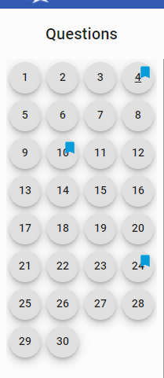

Individuals have two attempts to pass the e-Assessment. If they fail the first e-Assessment, they will be given their marks score.
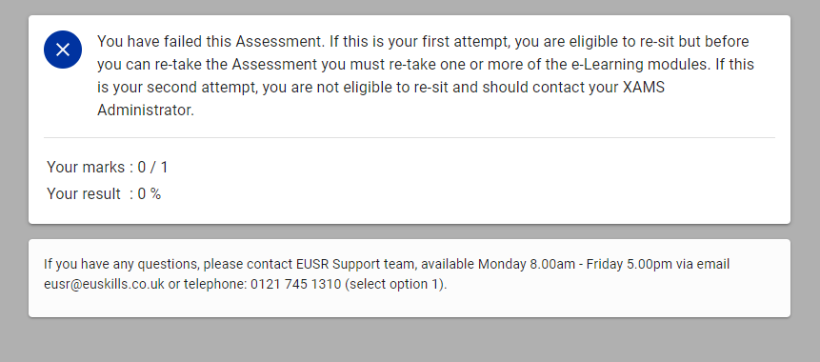

The individual may need to re-take the e-Learning modules they failed before they can re-sit the e-Assessment.
If the individual fails both the initial test and the re-take they will be required to complete the Face-to-Face training with an Approved Trainer.

Individuals who pass the e-Assessment receive the on-screen message below:
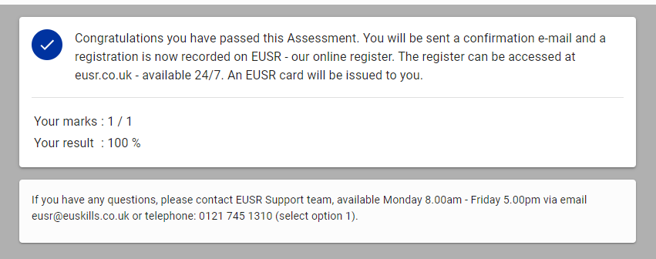

Once completed, the results are processed, EUSR is updated and registration cards are processed.

Appendix One – SCO Combinations and Advisory Timings

SCO Combinations
After completing the initial booking screen for the combination programme, you will need to select the modules required.
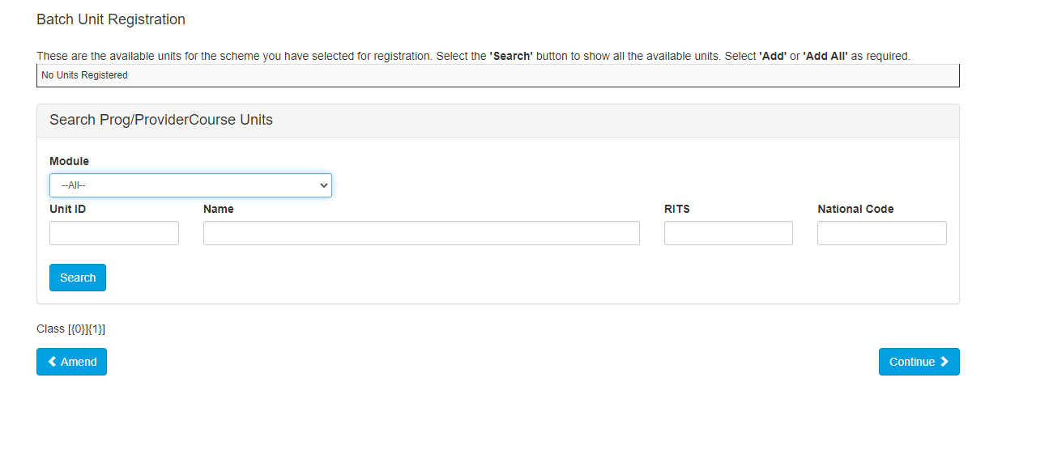The Module drop down will confirm all available combinations for the programme. Once selected the modules will appear at the bottom of the screen. You will need to select ‘Add’ to apply the modules.

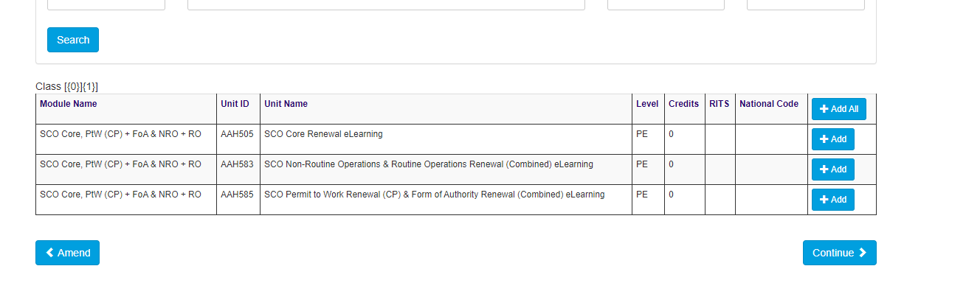Once selected these will be assigned to the batch.

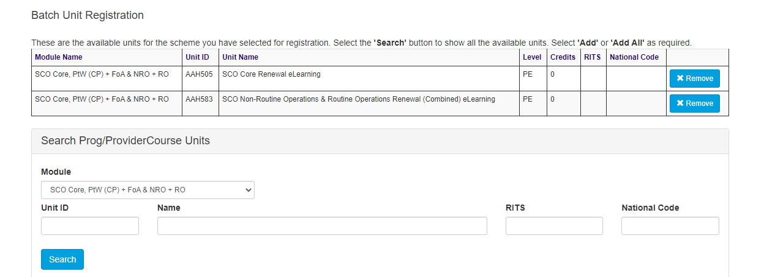

This will then need to be confirmed and the batch will be created.
You are then able to continue the process and add addition individuals.

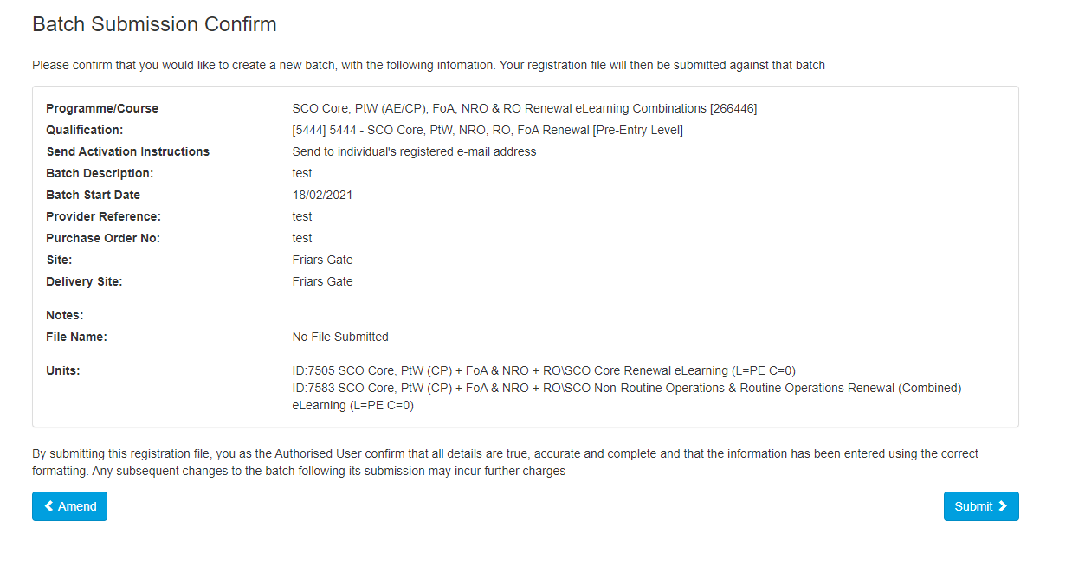

Advisory SCO Timings
The timings below are based on an average identified during testing. Individuals may take longer or complete in a shorter time period.

SCO Core Renewal – 65 minutes
SCO Permit to Work – 50 minutes
SCO Non-Routine Operations – 80 minutes
SCO Routine Operations (Full) – 75 minutes
SCO Routine Operations (Lite) – 45 minutes
SCO Form of Authority (Full) – 50 minutes
SCO Form of Authority (Lite) – 40 minutes
SCO Permit to Work and Form of Authority (Combined) – 70 minutes
SCO Non-Routine Operations and Routine Operations (Combined) – 100 minutes

**Please note**
The above timings do not include the assessments.

