SHEA

e-Assessment Administration Guide

This Guide is for SHEA e-Assessment hosted on Energy & Utility Skills’ CBL system.

CBL Administrators administer the course on behalf of individuals who are taking the assessment and so the first step is to appoint a CBL Administrator within your organisation – you may have more than one if needed.

A ‘CBL Administrator Registration Form’ will need to be completed – and counter-signed by an appropriate manager or director for each CBL Administrator and submitted to us by email to quality@euskills.co.uk.

When we process the ‘CBL Administrator Registration Form’, if the CBL Administrator does not already have an EUSR registration and ID, they will receive a system generated email confirming their EUSR ID number and a link to access ‘My Account’ on the Authorised Users section of the EUSR website; they will first be asked to reset their password. Those individuals who are already registered on EUSR will already have access to ‘My Account’ but they will now have additional functionality eg access to ‘Training Delivery’.

A CBL Administrator can perform the following actions:

- Issue e-Assessment activation for the individual
- Track progress of individuals
- View existing registrations
- Resend e-Assessment activation instructions
- Change contact details for e-Assessment activations
- Cancel e-Assessment activations (prior to the assessment being completed)
- View completed e-Assessments

1. Authorised User section of EUSR website

Login to the Authorised User section of the EUSR website using your username/EUSR ID and password.

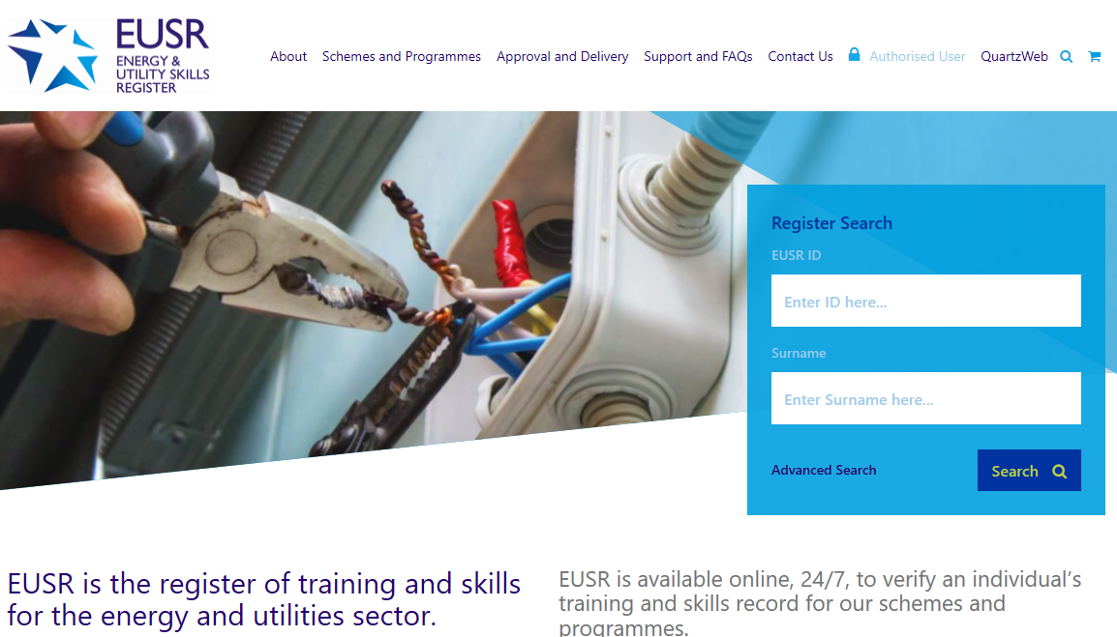
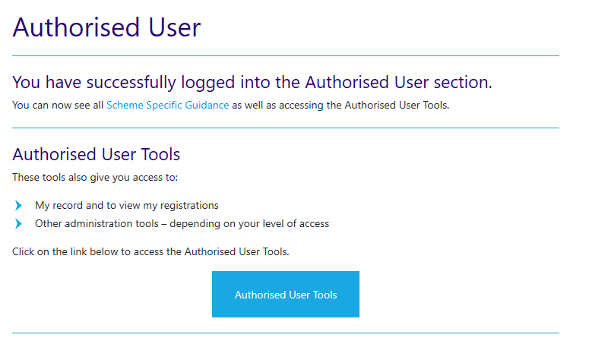
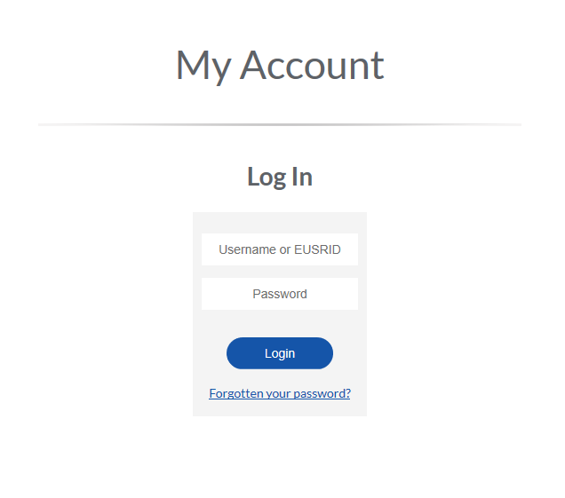

If you have any problems logging into the Authorised Users section of the EUSR website, please call the EUSR Support team on: 0121 745 1310 (select option 1).

2. Purchase Order Number(s)

There must be a valid Purchase Order in place before individuals can be activated for the e-Assessment via our CBL system

You can view or amend the Purchase Order number we will allocate to your e-Assessment activations.

Select the ‘My Account’ tile and then ‘CBL Payment Options’ from the menu.

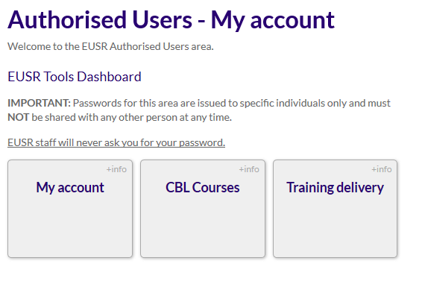
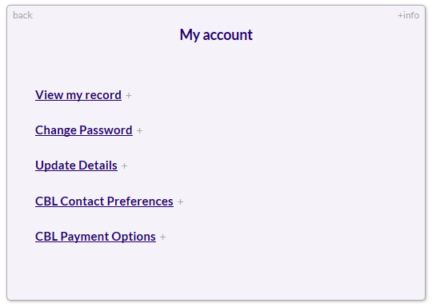

To amend the Purchase order details, select CBL Payment Options and then select ‘Update’. Once you have made the changes, select ‘submit’.

3. e-Assessment Activations

An individual can access the e-Assessment by clicking on a link within a system generated email that is sent to them by a CBL Administrator – this is sometimes called an ‘activation link’.

To send an ‘activation link’, click on the ‘Training Delivery’ tile and then select ‘E-learning administration’ from the menu.

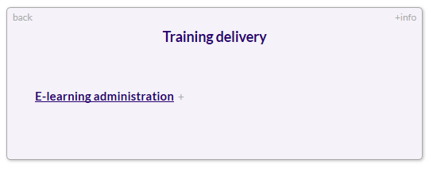

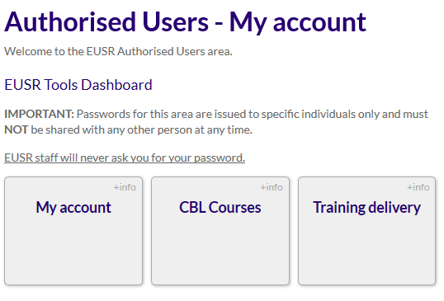

You will see a table listing your existing activations and a link to activate a new individual.

To activate a new individual, select “Activate a new candidate here”. Enter the EUSR ID and surname of the individual to be activated and click “Find Candidate”.

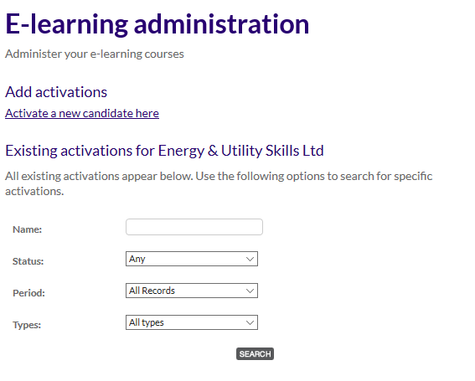

The EUSR ID number of the individual can be verified or obtained using the EUSR Register Search on the EUSR website www.eusr.co.uk

From the drop-down box, select the e-Assessment to be taken – this will be SHEA E-Assessment.
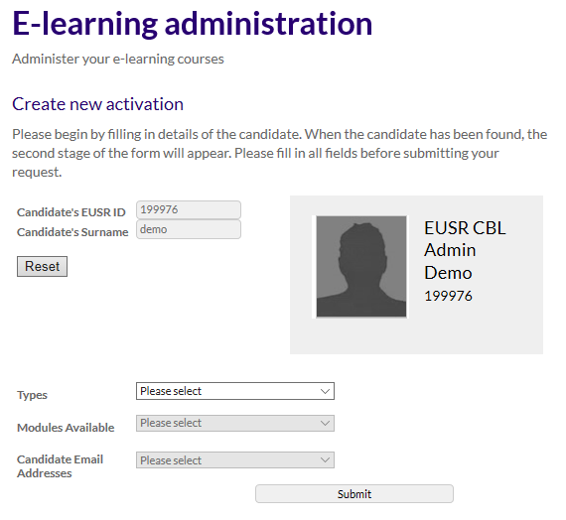

You can choose whether the activation instructions are sent to the individual’s email address registered in EUSR, your registered email address or to a specified email address. Selecting the last option will prompt you to provide an email address.

If you have any problems finding an individual on the EUSR Register, please call the EUSR Support team on: 0121 745 1310 (select option 1).

Select “Submit” to complete the e-Assessment activation.

Upon successful e-Assessment activation, you will receive an automated “Candidate Activation Successful” email.

It is easy to reissue or cancel an activation link. On the individual’s activation page, select the appropriate action from the menu under ‘ACTIONS’ at the bottom of the page.

You can also change an individual’s contact details. On the individual’s activation page, select ‘Change Contact Details’ from the menu under ACTIONS at the bottom of the page.
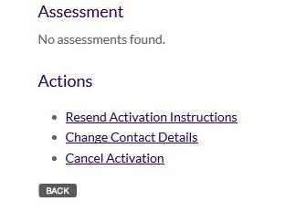

4. e-Assessment

The individual will be asked to confirm their name and date of birth both at the start and mid-way through the e-Assessment. If the details entered are not correct, the e-Assessment will terminate, and you will need to re-issue an activation link.

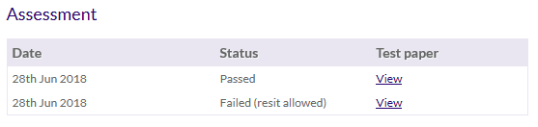

Once the individual has completed the e-Assessment, the test paper can be viewed. This option will only appear once the individual has attempted the e-Assessment and either failed or passed.

If an individual fails their first e-Assessment, they will be given a second attempt. If they fail the second attempt, they will have to complete a face-to-face assessment.

Upon successful completion, a confirmation email will be sent to both you and the individual.

5. Activation links for CBL to individuals without an EUSR ID

Before you can send a link to the e-Assessment, you will need to get an EUSR ID number for the individual from within our online registration system, QuartzWeb. You will need to contact the EUSR Support team who will create a ‘one-time’ pre-registration Batch for you. They will also talk you through the process for the next time you need to get an EUSR ID number for an individual.

Switching Roles in QuartzWeb
Log in to your QuartzWeb account. In the top right-hand corner of the screen it will state the role you are logged in as.

This will vary depending on the QuartzWeb role you are logged in as, for example Trainer or Administrator. Please click on the role title to enable you to switch.

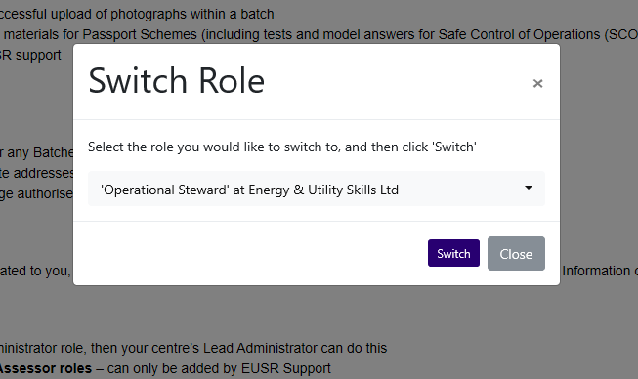

Please select the drop down and change your role to one within your e-Assessment centre name (the one with (CBL) at the end of the centre name).

For example:

Administrator at Energy and Utility Skills
‘change to’
Administrator at Energy and Utility Skills (CBL).

Choose the right centre name – those organisations who deliver e-Assessment will have two different centres to choose from; one centre name will be for all non e-Assessments and the other for e-Assessment only. It will be easy to select the right centre name, as the centre which must be used for e-Assessment will have (CBL) added at the end of the centre name

If you are allocated more than one role in QuartzWeb, (for example you could also be an ‘Administrator’), then you must make sure that you are logged in under the right role. It’s very easy to switch roles when you are logged in. If you are not logged in as a ‘CBL Administrator’ you will not be able to access your e-Assessment (CBL) centre.

Once logged in, from the landing page select the tab ‘Batch Actions’ then select ‘Your Batches’
- Then select the batch (the one created for you by EUSR Support) – there will only be one batch listed (you will not need to create a batch)
- Add the individual’s details to this batch – this generates an EUSR ID Number - this tool also allows you to upload photos for new individuals, it also allows you to update existing individuals’ photos
- There is no need to submit the batch – this batch is purely for the purposes of allocating an EUSR ID Number

Adding an Individual
To enter an individual please select the ‘Enter Single Individual Registration’

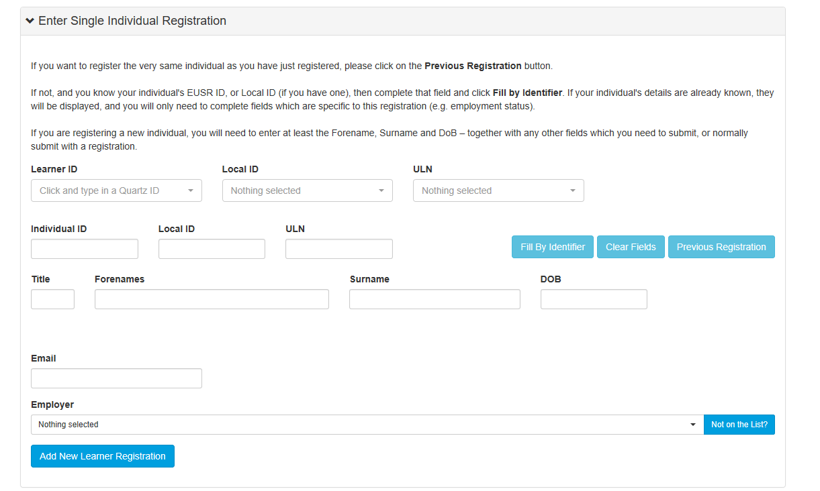

Complete the required fields:
- First name
- Surname
- Date of Birth
- Email address

Once completed select ‘Add New Learner Registration’

The individual will now be added to the batch and an ID number created.
You will need to add the photo
Select ‘Actions’ ‘Add Photo’

The EUSR ID number can then be added in our CBL system through the Authorised User Section of the EUSR website.

If you have any queries at all relating to your role as a CBL Administrator, or activating individuals for e-Assessment, please call the EUSR Support team on 0121 745 1310 (select option 1) or email eusr@euskills.co.uk

